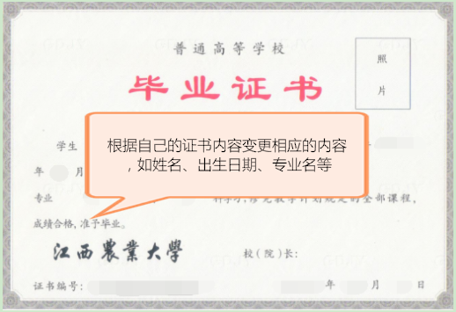

JIANGXI AGRICULTURAL UNIVERSITY

Certificate of Graduation
This is to certify that Mr/Ms Zhang Shan, who was born on June 25, 1990, majored in Animal Science at Jiangxi Agricultural University from September 2012 to July 2016. He/she is entitled to graduate after having passed all the required four-year undergraduate courses in conformity with the national educational plan.

President：(校长签字的拼音)
Jiangxi Agricultural University

Certificate Number:1041012016XXXXXXXX Date:July 1, 2017

